24.15: a) 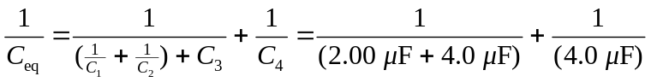
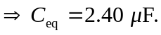
Then, and But also, 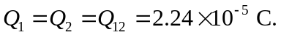
b)
c)

